Previously we are using js function by calling onclick or similar things from html page:

Now we can use it everything doing at js file.

There are many types of event listener: check: <https://developer.mozilla.org/en-US/docs/Web/Events#Most_common_categories>

See video ‘many type of event listener’

Example 1:

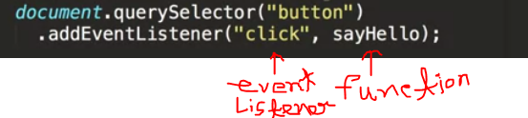

Example 2:

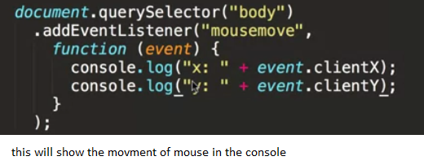

Example 3:

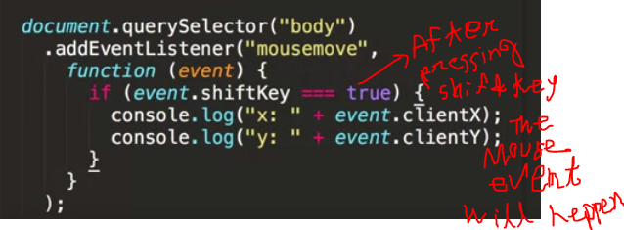

1.

No need to call :

onclick="sayHello();

at html page.

Instead of that we will use:

 document**.**querySelector("button")

**.**addEventListener("click", sayHello);

Or

  document**.**querySelector("button")

**.**onclick = sayHello;

see the video ‘Handling Events Coursera’

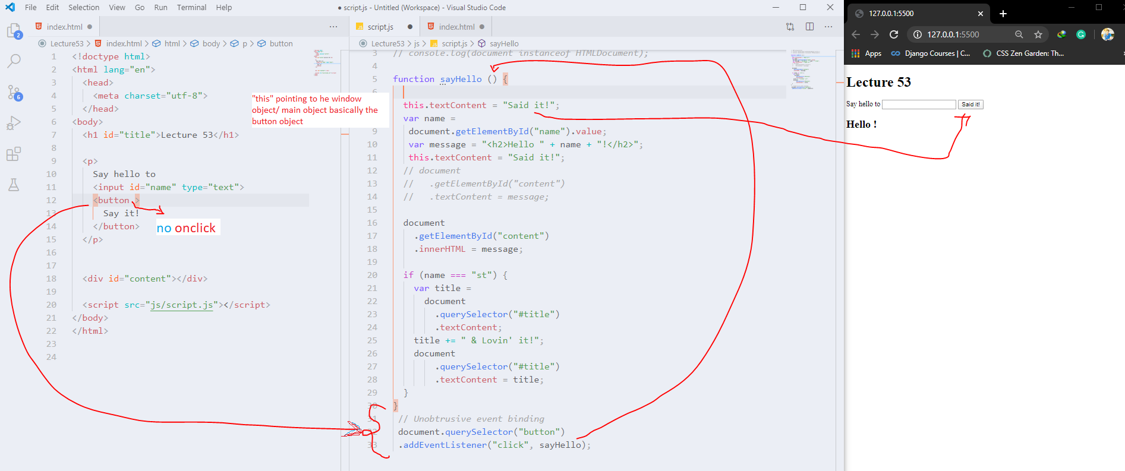

Now here we can use ‘this’ kew word

To point the button name and change it

2.Now when the click or basically the event happens then do that : document.addEventListener(“DOMContentLoaded”)

See video: ‘Handling Events Coursera’

Example: js

//*Event handling*

document**.**addEventListener("DOMContentLoaded",

function (event) {

function sayHello (event) {

this**.**textContent = "Said it!";

var name =

document**.**getElementById("name")**.**value;

var message = "<h2>Hello " + name + "!</h2>";

document

**.**getElementById("content")

**.**innerHTML = message;

if (name === "student") {

var title =

document

**.**querySelector("#title")

**.**textContent;

title += " & Lovin' it!";

document

**.**querySelector("h1")

**.**textContent = title;

}

}

//*Unobtrusive event binding*

document**.**querySelector("button")

**.**addEventListener("click", sayHello);

}

);

By using this js we can mention the script tag inside the head in html page.